**E-News Letter**

**Nagar Parishad Sikar**

**Introduction**

Municipality is usually known as an urban administrative division having corporate status and usually powers of self –government or jurisdiction. The term municipality is also used to mean the governing body of a municipality. A Municipality is a general – purpose administrative subdivision, as opposed to a special – purpose. The term is derived from French “municipalite” and Latin “Municipalis”.

There are 188 urban local bodies in Rajasthan After enactment of 74th Constitutional Amendment Act, the Local Bodies, which were previously not the part of the Constitution of India, have now been assigned the Constitutional Status. There are 7 Corporations 34 Councils and 147 Municipalities. Total 188 ULBs in the State.

The purpose of municipal governance and strategic urban planning in a country is to create effective, responsive, democratic, transparent, accountable local governance framework organized according to a rational structure that promotes responsiveness and accountability; to provide responsive policy guidance and assistance to sub-national entities; to strengthen the legal, fiscal, economic and service delivery functions of municipalities; and to foster greater citizen participation in the governance of local bodies.

The functions of municipal bodies broadly relate to public health welfare, regulatory functions, public safety, public infrastructure works, and development activities.

Public health includes water supply, sewerage and sanitation, eradication of communicable diseases etc. welfare includes public facilities such as education, recreation, etc. regulatory functions related to prescribing and enforcing building regulations, encroachments on public land, birth registration and death certificate, etc. public safety includes fire protection, street lighting, etc. public works measures such as construction and maintenance of inner city roads, etc. and development functions related to town planning and development of commercial markets.

uxj fudk;ks )kjk fd;s tkus okys egRoiw.kZ dk;Z”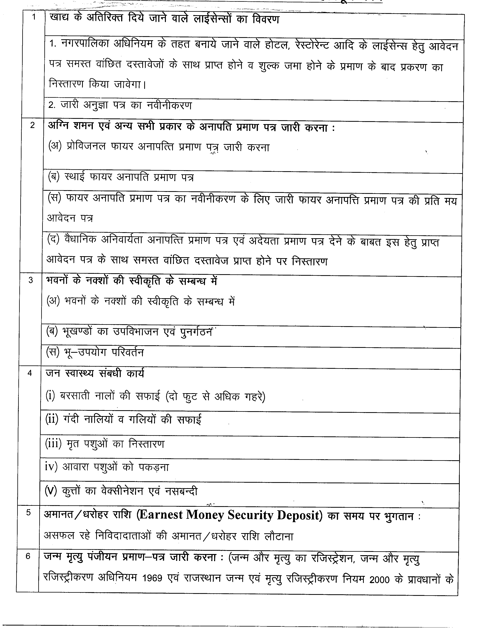

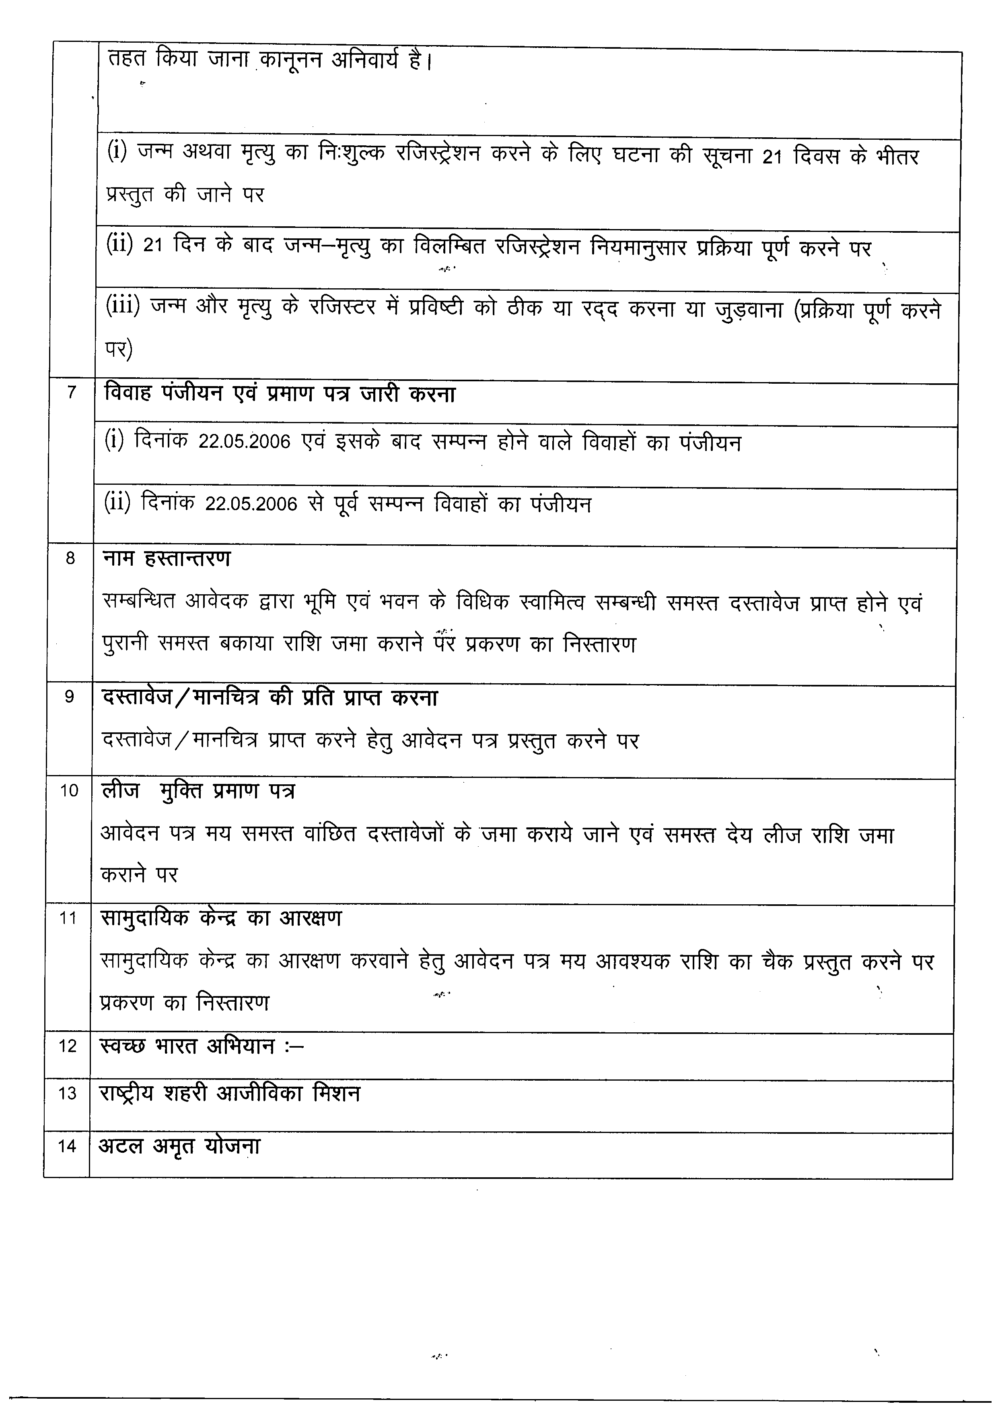

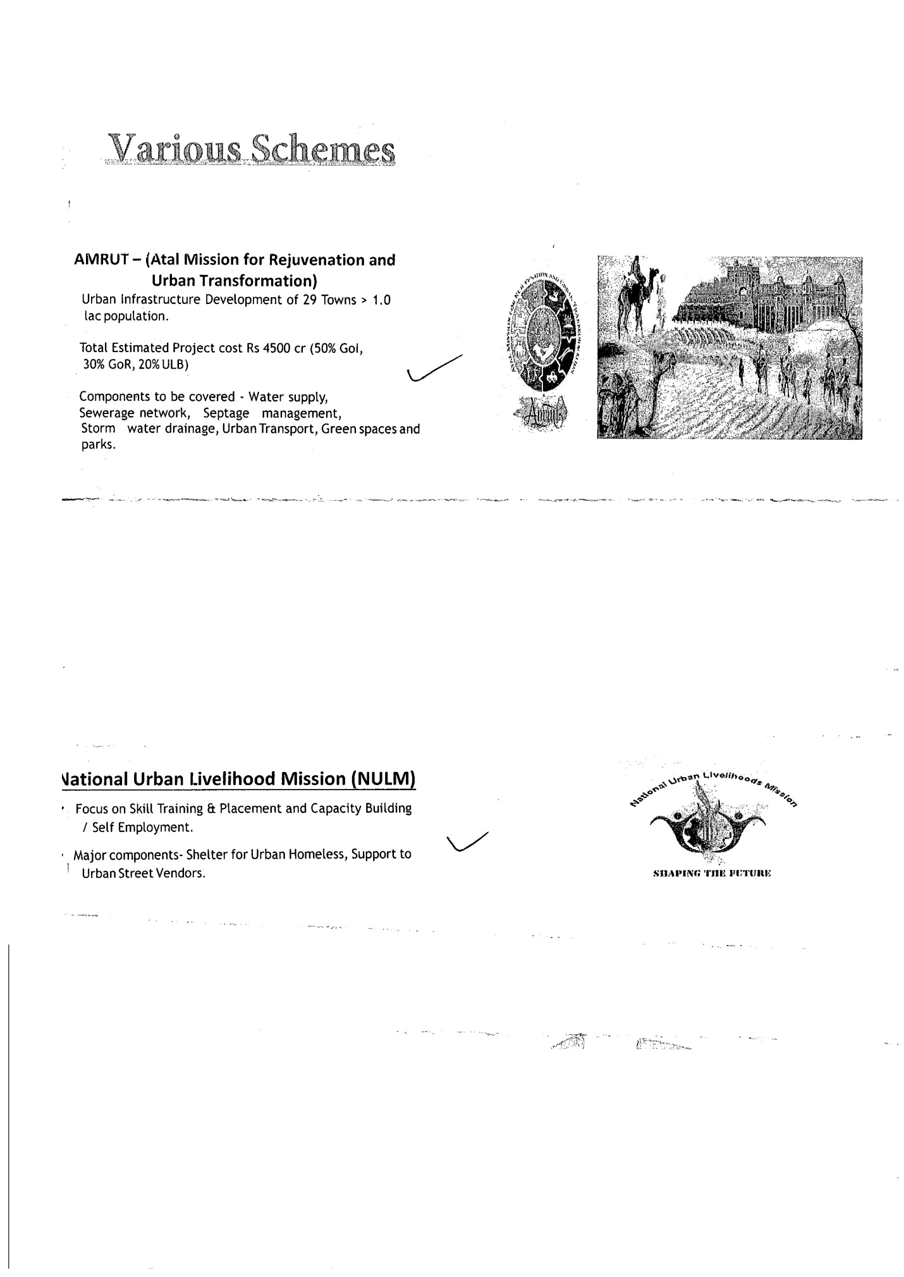

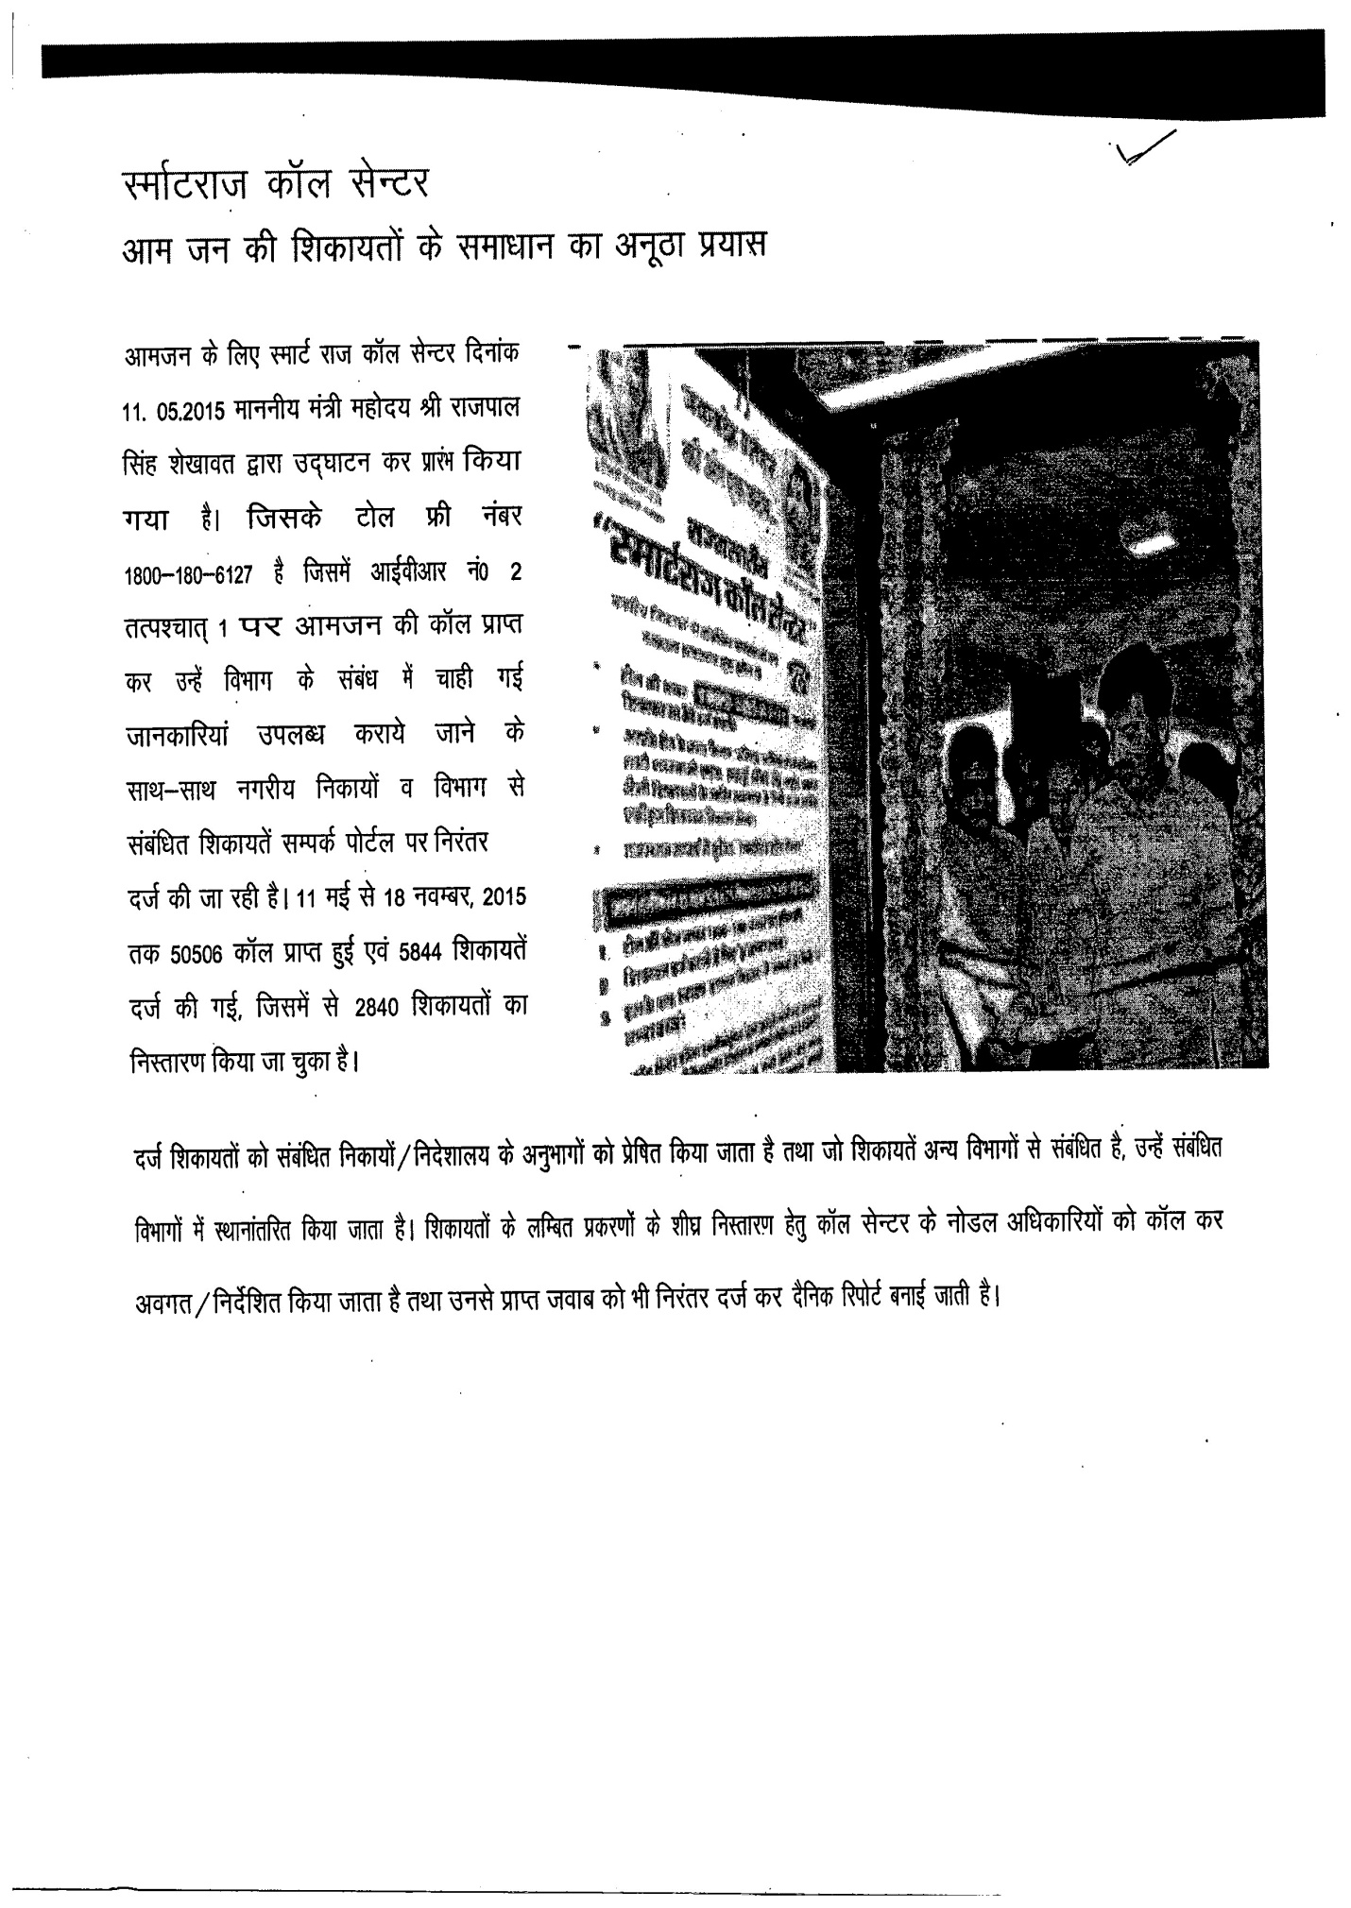

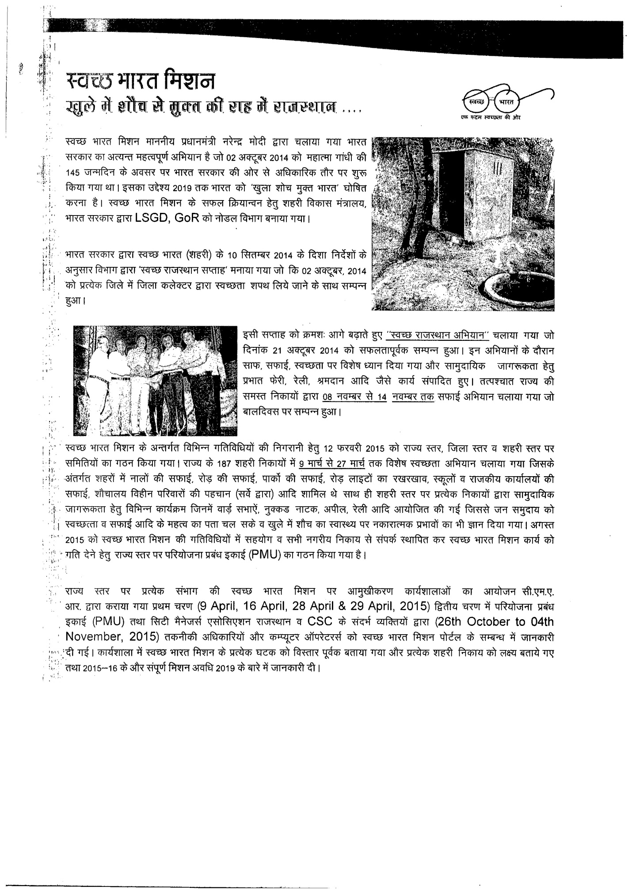**jktLFkku lEidZ iksVZy ij ntZ f'kdk;r dk fuLrkj.k**

uxjh; fudk; esa jktLFkku lEidZ iksVZy ds ek/;e ls Qjojh&2016 rd vketu ls izkIr f'kdk;rksa ds fuLrkj.k dh fLFkfr %&

1. dqy izkIr f'kdk;r %&124
2. dqy fuLrkfjr %& 105
3. 'ks"k fuLrkj.k ds izfØ;k/khu gSA

**fudk; {ks=ksa esa fLFkr Hkw& [k.M@ Hkouksa dh cdk;k yht jkf’k ij ns; C;kt esa NwV**

jktLFkku uxjikfydk uxjh; Hkwfe fu"iknu fu;e 1974 ds fu;e 32 ds varxZr iznRr 'kfDr;ksa dk iz;ksx djrs gq, jkT; ljdkj }kjk jkT; ds fudk; {ks=ksa esa fLFkr Hkw&[k.M@Hkouksa dh cdk;k yht jkf’k ij ns; C;kt esa NwV iznku dh xbZ gSA

iwoZ dh leLr cdk;k okf"kZd yht jkf’k e; pkyw o"kZ dh yht jkf’k ,d eq’r tek djkus ij cdk;k yht jkf’k ds C;kt esa 50 izfr’kr jkf’k dh NwV ns; gksxh rFkk iwoZ dh leLr cdk;k ,oa vkxkeh leLr o"kksZ ds fy, ns; yht jkf’k ,d eq’r tek djkus okys yht gksYMlZ dks cdk;k yht jkf’k ds C;kt esa 'kr izfr’kr NwV ns; gksxhA ijUrq NwV 30 twu ]2016 rd vkosnu djus ,oa 30 flrEcj] 2016 rd yht jkf’k tek djkus ij gh ns; gksxhA jkT; dh leLr uxj fuex ifj"kn ,oa ikfydk {ks= esa vf/kd ls vf/kd yksxksa dks NwV dk ykHk fey ldsA blds fy, f’kfoj yxk;s tk;sxsaA

**Contact Us**

**Chairman**

Ph No**. 01572-270635**

**Commissioner**

Ph No. **01572-270635**

Call Center Toll free No.:- 1800-180-6127